**PUBLIC TRANSPORTION OPTIMIZATION**

**IoT – PHASE – 2**

**INNOVATIVE DESIGN**

* **Introduction:**
* Definition: Public transportation includes services like buses, trains, and ferries, while Intelligent Transportation Systems (ITS) have a subsystem called Smart Public Transportation (SPT).
* SPT Functionality: SPT intelligently monitors public transit networks, ensuring their operation and providing clients with excursion and system information.
* Technologies Enabling SPT: Smart public transport systems rely on technologies like Geographic Information Systems (GIS), Automatic Vehicle Location Systems (AVLS), Traveler Information Systems (TIS), and the Internet of Things (IoT).
* IoT in Public Transportation: IoT plays a key role in improving public transit reliability by addressing issues like wait times and traffic congestion.
* Wireless Communication: Wireless technologies are used for managing and controlling public transportation systems.
* Examples of IoT in Public Transportation: Various IoT technologies such as GSM, GPS, Wi-Fi, RFID, and Arduino have been used to develop smart bus tracking and monitoring systems.
* Real-Time Bus Tracking: IoT-based systems enable real-time tracking of buses, providing location information to passengers via mobile apps.
* Ticketing and Payment: Some systems use RFID, GPS, and mobile apps for automatic ticketing and fare deduction from passengers' E-wallets.
* Data Transfer and Display: Data collected from buses, including location, speed, and passenger count, is transferred to cloud servers and displayed on mobile applications.
* Goal of IoT in Public Transportation: The ultimate goal of IoT in public transportation is to reduce passenger wait times and enhance the overall user experience.
* **Implementable model:**
* Prototype Overview: The prototype consists of an Android application designed for real-time bus information. It displays bus data like location, speed, distance, and arrival time on Google Maps.
* Hardware Components: The system includes an ESP32 with Wi-Fi, a GPS module, and an Android app connected to a server. These components are installed on each bus, powered by the bus itself.
* GPS and ESP32 Operation: GPS receives satellite signals to determine the bus's latitude, longitude, and speed. The ESP32, equipped with Wi-Fi, collects this data and uploads it to a Blynk Server via wireless communication.
* User Access: Users access real-time bus information via the Android app, which is IoT-enabled and retrieves data from the Blynk Server.
* Distance and Arrival Time: The system calculates distances using the Haversine formula and estimates arrival times, which are displayed within the Android application.

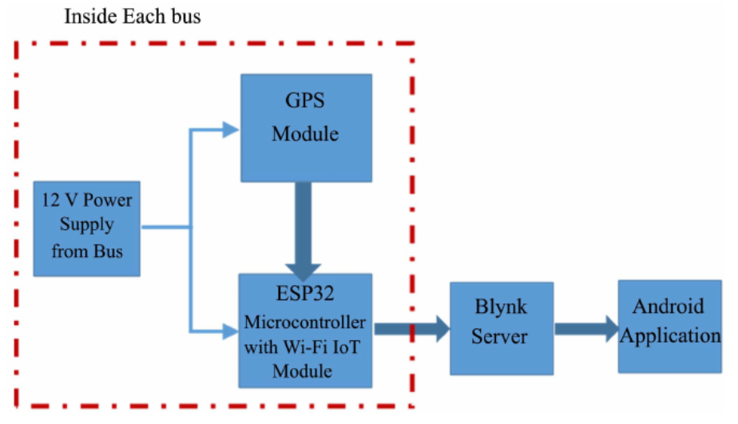

* **Components and their roles:**
* ESP32 Micro-controller:

The ESP32 is an open-source microcontroller equipped with a Wi-Fi module, making it an affordable and energy-efficient system-on-a-chip (SOC). This microcontroller features a dual-core design and includes various built-in components like Wi-Fi, Bluetooth, as well as numerous peripheral interfaces such as IR, SPI, CAN, Ethernet, and temperature sensors.

* GPS module:

GPS (Global Positioning System) is employed to determine the precise location and track the movement of buses through satellite communication. GPS satellites are in orbit around the Earth, ensuring global coverage. For accurate GPS data, a minimum of three satellites is required. The NEO-6M GPS module, chosen for this system, is compact and energy-efficient, making it well-suited for tracking purposes. It operates on a 3.3 V power supply, which is provided by connecting it to the ESP32's 3.3 V pin.

* Mobile Application:

The Android application plays a crucial role in the success of this system as it serves passengers by offering information about their required bus. It acts as a bridge connecting users to the server. For this system, the Android app is built using the Blynk platform. Blynk is an IoT platform known for its ability to quickly create impressive applications for both Android and iOS smartphones. It can be employed to control various devices such as Raspberry Pi, ESP8266, ESP32, and more. The Blynk platform consists of Blynk libraries, a Blynk server, and Blynk apps.

The Android app, as depicted in Figure, features a map that displays the passenger's location and tracks the current bus location. It provides estimated arrival times, the bus's speed, and identifies the nearest bus to the user by calculating the distance between the passenger and the bus's location.

* **Flowchart:**

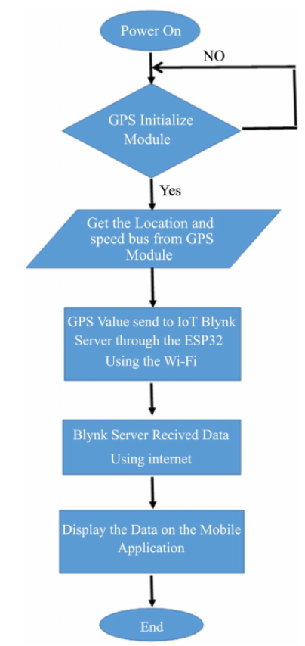

* **References:**
* <https://www.sciencedirect.com/science/article/pii/S2352146522005300>
* <https://www.researchgate.net/publication/355708623_Design_an_Intelligent_Real-Time_Public_Transportation_Monitoring_System_Based_on_IoT>